

Woning voor u

Online real estate websites

Design document

Ahmad Alkrad | 3231402

Barra Abd Al Fattah | 3004503

Supervised by professor  
Avetyan,Rafayel R.

# Index

Contents

Index 2

Introduction 3

Target audience 3

Site Map……………………………………………………………………………………………………………………………….4

Wireframes 5

Homepage 5

Log in 6

Sing up 7

Profile 8

About Us 9

Search Result 10

Contact us 11

Homepage Design 12

Homepage Design Widescreen 13

Figure 1 - Homepage 5

Figure 2 – Log in 6

Figure 3 – Sing up 7

Figure 4 - Profile 8

Figure 5 – About us 9

Figure 6 – Search result 10

Figure 7 – Contact Us 11

# Introduction

In oreder to make the real estatie more easier , we decided to make an website to help people to register for a house online , without doing any effort.  
We are offering houses located in the Netherladns

# Target audience

Target audience manly consists of male residents in the netherlands between 18-35 years of age and average income of €63.6k

|  |  |  |  |  |  |
| --- | --- | --- | --- | --- | --- |
| Name | Max | Jack | Antita | Edward | Marielle |
| Gender | M | M | F | M | F |
| Age | 33 | 22 | 30 | 27 | 18 |
| Location | Netherlands | Netherlands | Netherlands | Netherlands | Netherlands |
| Occupation | Student | web developer | Teacher | barber | Student |
| Income | €24k | €80k | $60k | €130k | €24k |
| Web Use | 5-6 days/wk | 5-6 days/wk | 1-3 days/wk | 3-5 days/wk | 4-5 days/wk |

Sitemap

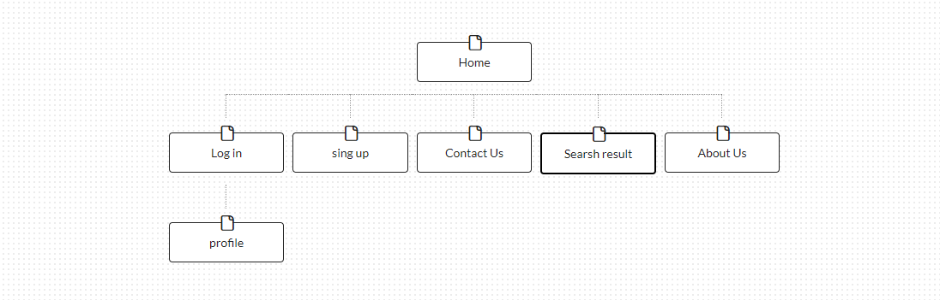

# Wireframes

## Homepage

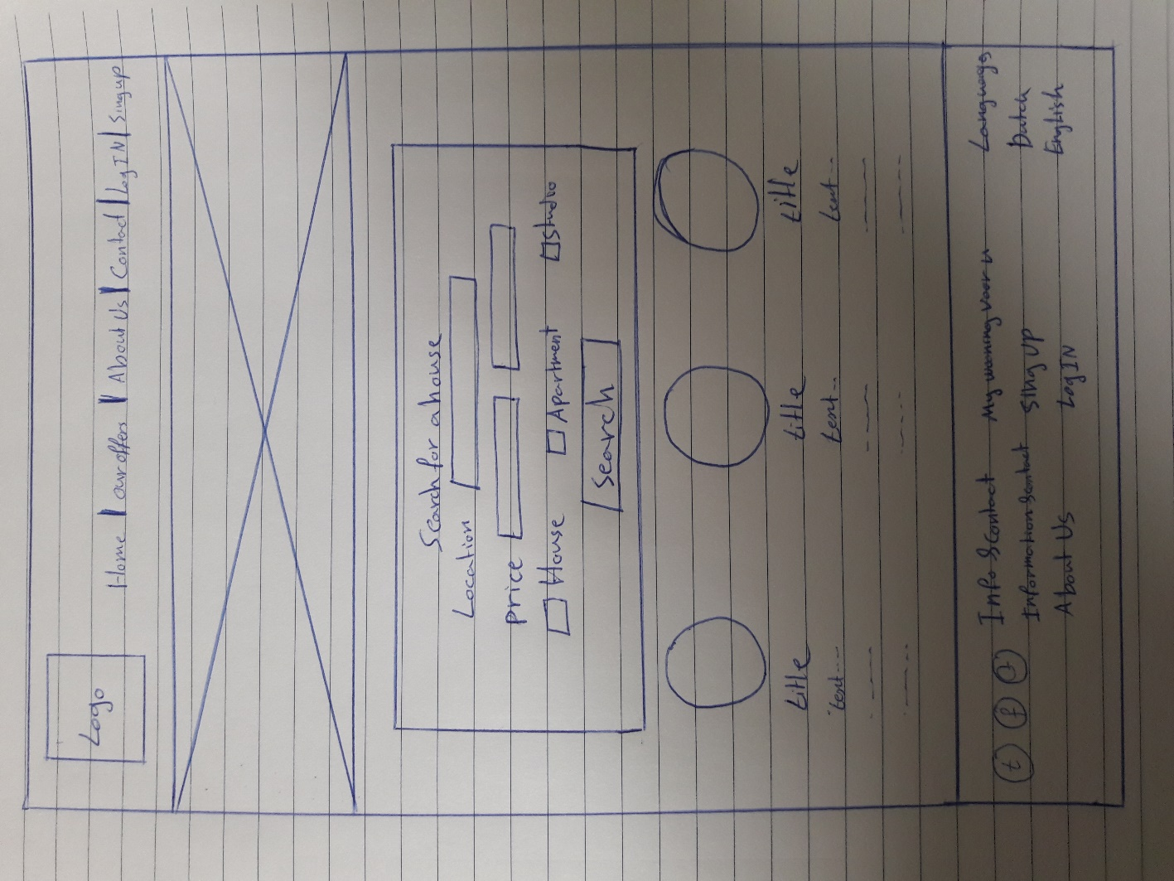

Figure 1 - Homepage

## Log in

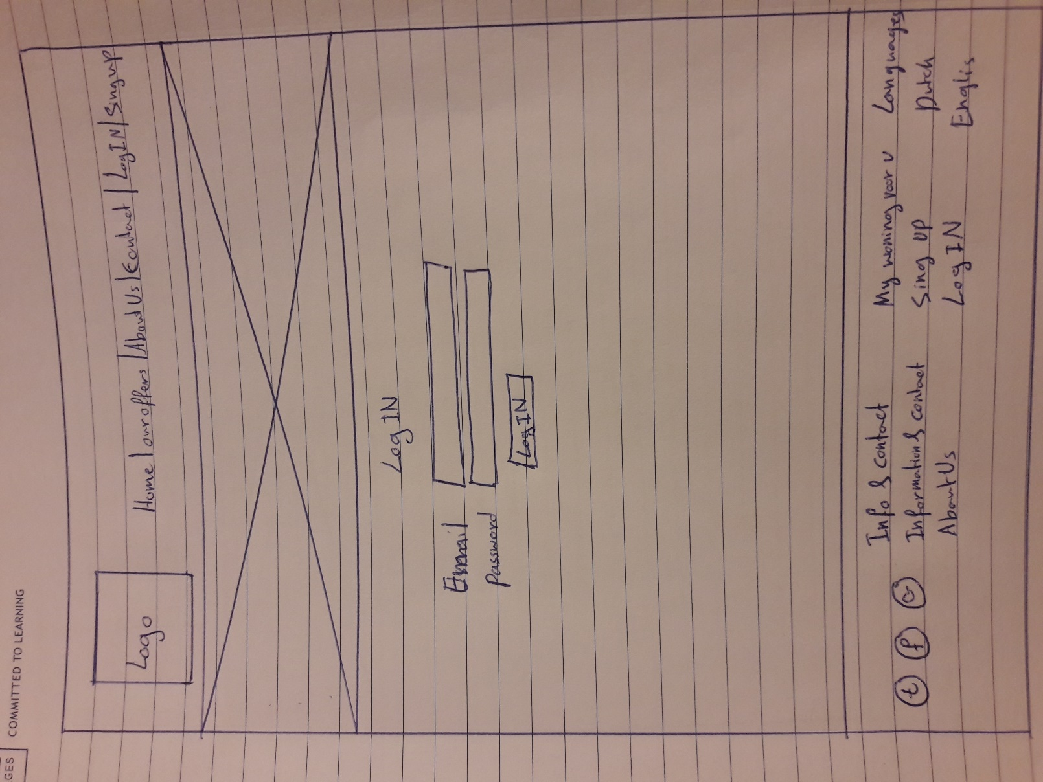

Figure 2 – Log in

## Sing up

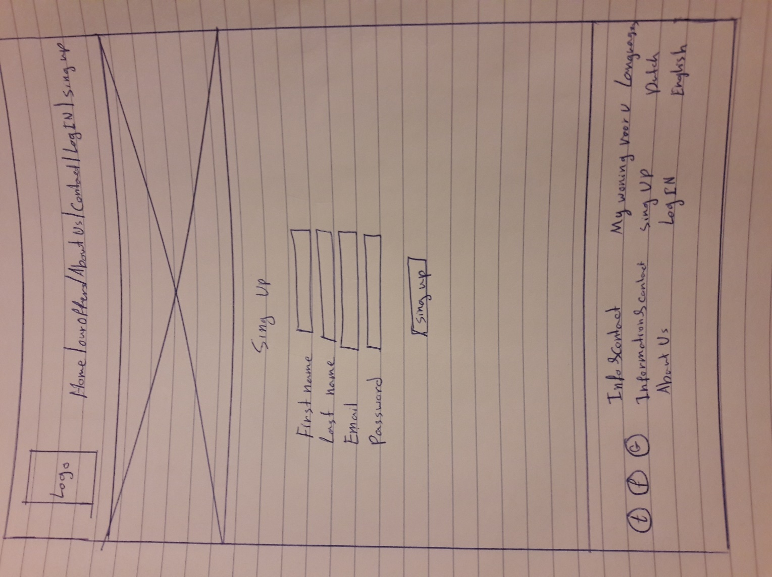

Figure 3 – Sing up

## Profile

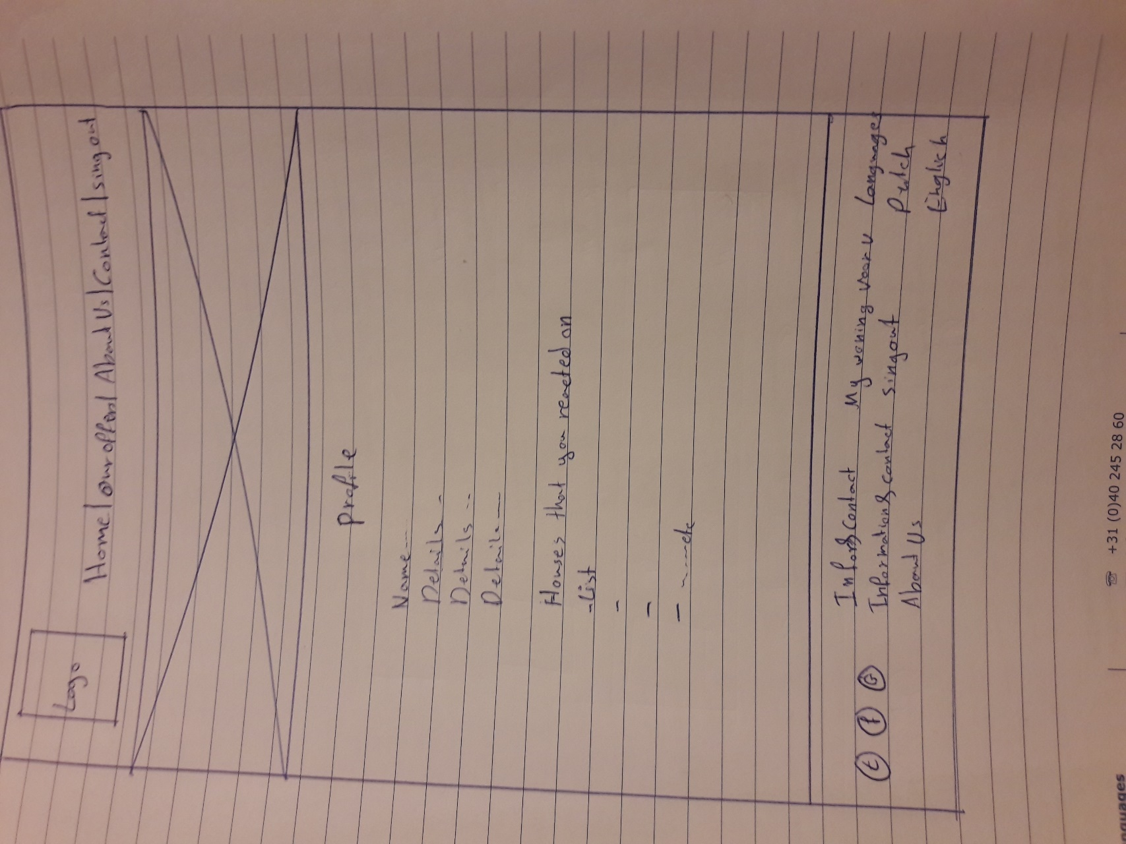

Figure 4 - Profile

## About Us

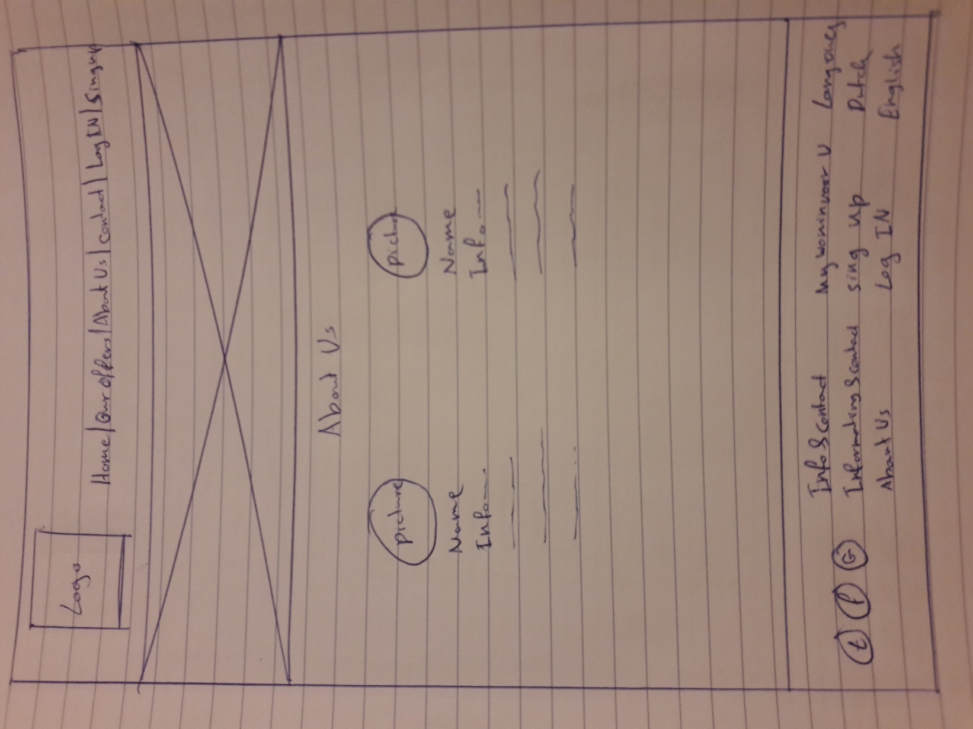

Figure 5 – About us

## Search Result

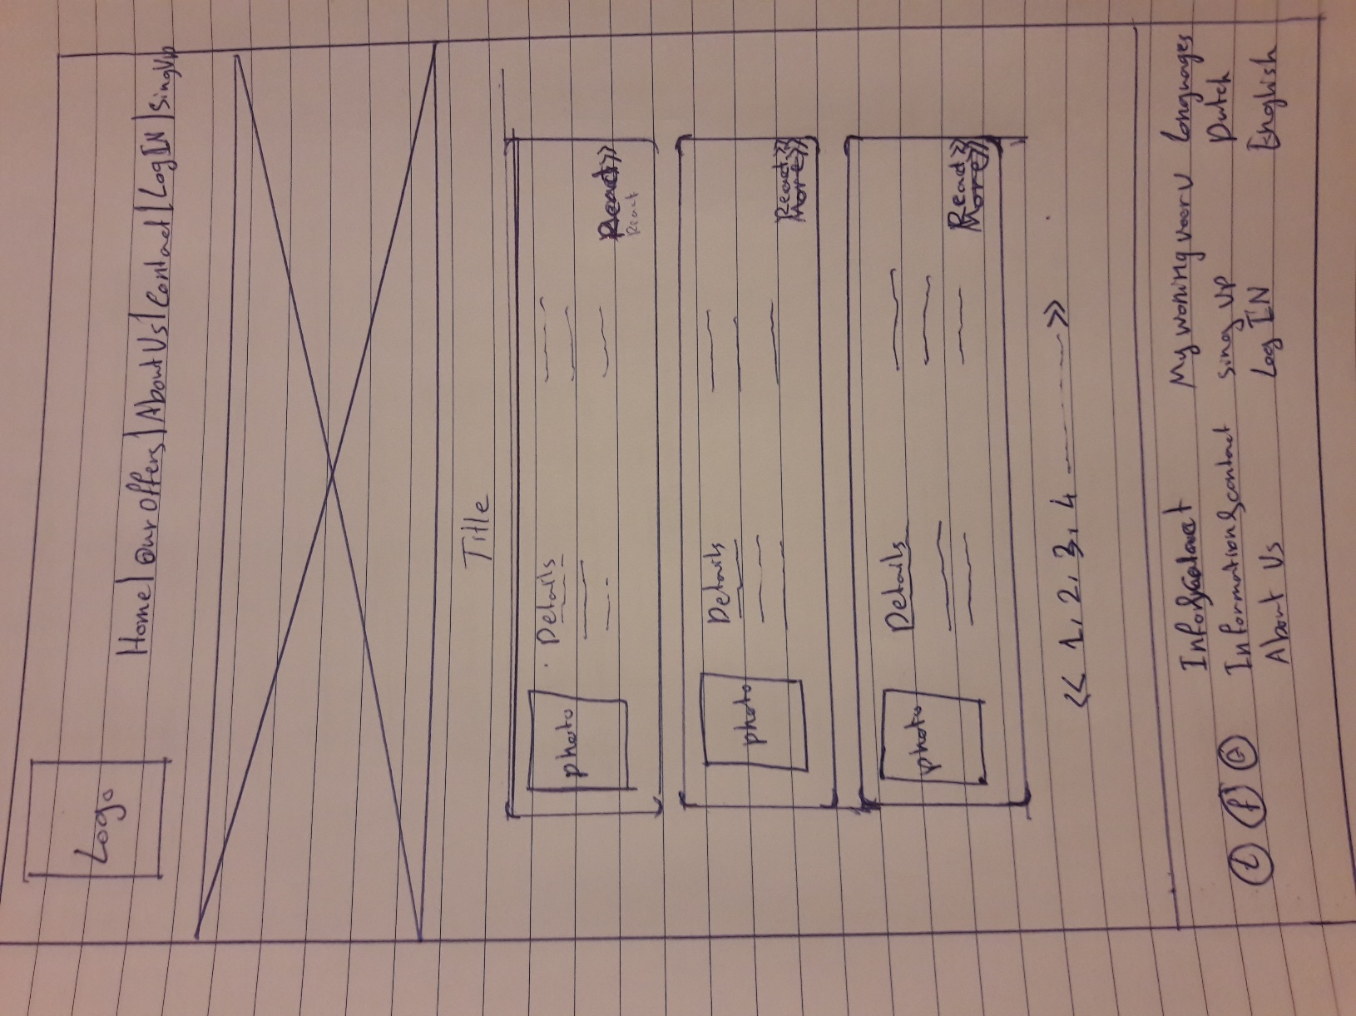

Figure 6 – Search result

## Contact us

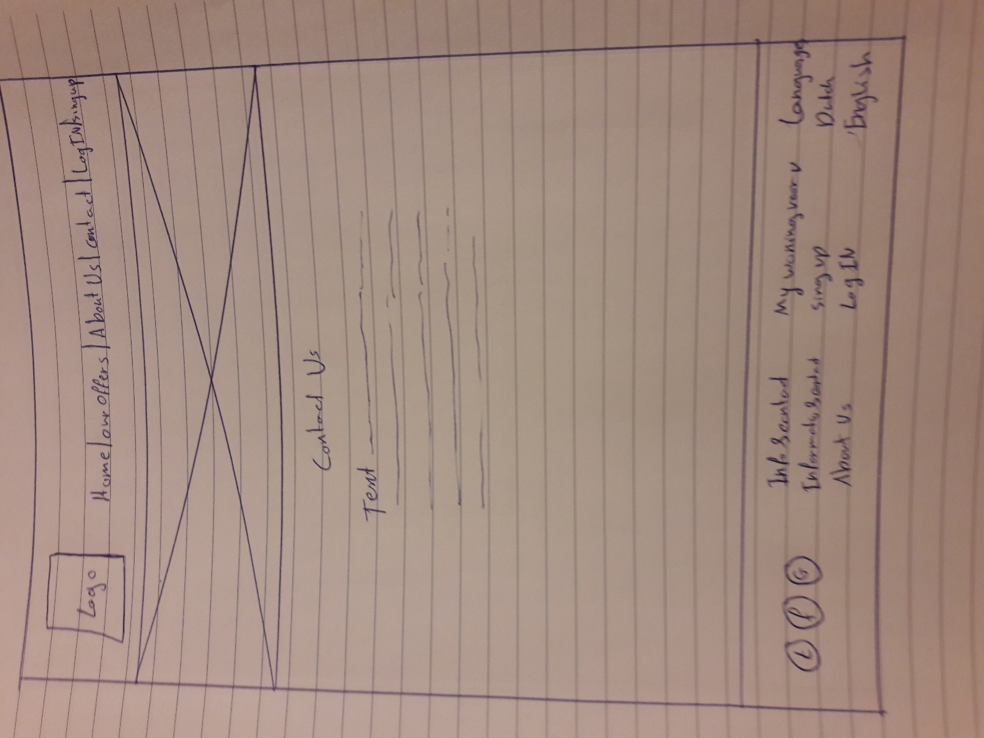

Figure 7 – Countact us

# Homepage Design

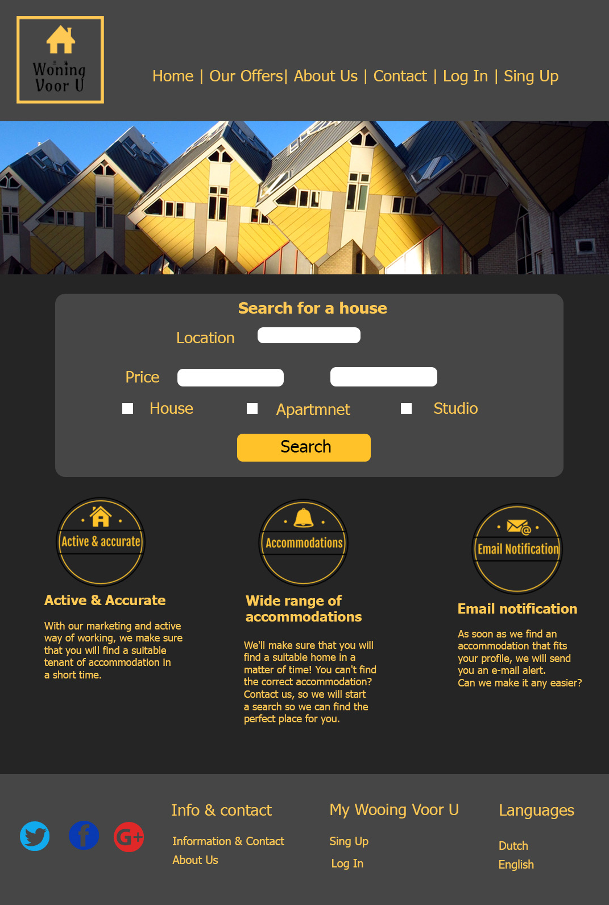

Figure 8 - Homepage Design

# Homepage Design Widescreen

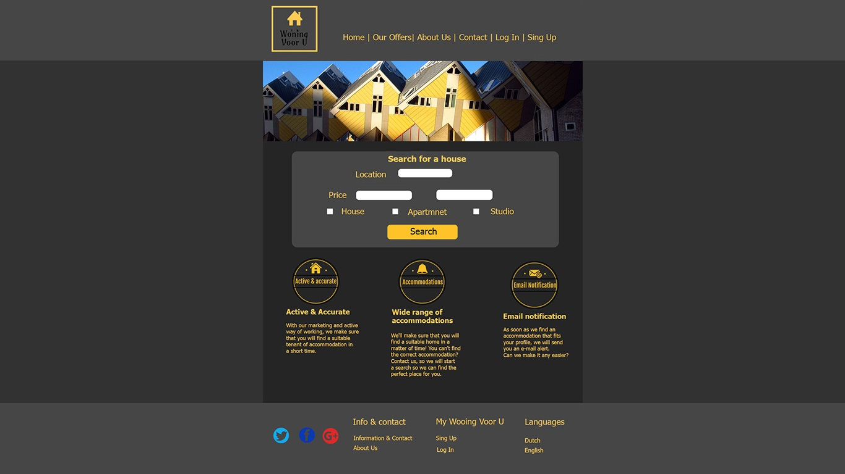

Figure 9 - Homepage Design